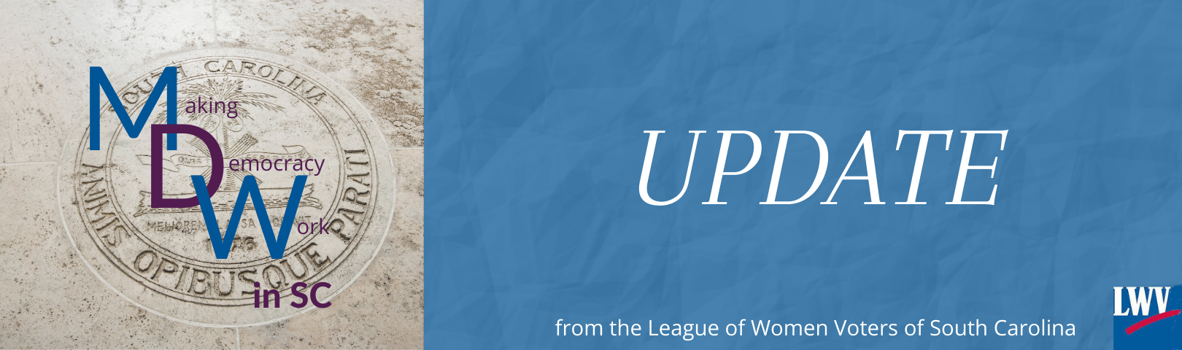

March 17, 2021 (Afternoon edition)

Making Democracy Work in SC: Crippling the Federal Government, In Constitutional Laws Subcommittee Tomorrow

The title sounds like an overstatement, but it isn’t. H. 3205, a resolution calling for an Article V Convention to amend the federal Constitution, is designed to realize the dream of wealthy extremists – shrinking government until it can be drowned in the bathtub. It is on the agenda for a meeting of the Constitutional Laws Subcommittee of House Judiciary tomorrow, Thursday March 18, at 9:00 AM in Blatt 516.

You are encouraged to read a detailed discussion of H. 3205, with links to supporting documents. https://my.lwv.org/sites/default/files/constitutional_convention_resolutions.pdf.

The resolution, co-sponsored by a very long list of representatives including House leadership, would add South Carolina to the list of states calling for a convention as authorized by Article V of the United States Constitution. Alleging that it establishes the ground rules under which the convention would operate, it demands:
- imposing “fiscal restraints” on the federal government,
- limiting the power and jurisdiction of the federal government, and
- enacting term limits for members of Congress

The resolution cannot do what it claims to do, restricting the conditions under which the convention would be held. Constitutional law experts agree that the Convention itself would set its rules, without reference to state attempts to restrict it. Everything in our Constitution would be at risk.

Who wants this bill? Very wealthy special interests are behind the push for an Article V Convention. They want a federal government that can’t stand in the way of their own power to do as they please. They have “grassroots” allies who fail to understand that this wouldn’t just stop the federal government from doing the things they don’t like. It would stop the federal government from doing many of the things essential to holding a 21st nation together and allowing it to function in the modern world.

What is at risk? Our entire federal Constitution, including the Bill of Rights, is at risk. Supporters claim this risk is exaggerated because amendments must be sent back to the states for approval. They count on using their vast financial resources to build public support to push such amendments through, focusing on superficially attractive slogans (“Rein in the federal government!” and “Balance the budget!”). State legislators would be under immense pressure to pass the amendments, often from people who do not understand that their own way of life is at risk.

Please oppose H. 3205. Testify against it, write to your legislators. This is not a harmless gesture of support for small government, it is a real and potentially catastrophic danger to our nation and our state. Supporters are much too close to the number of states they need to make this happen.

Lynn

Lynn Shuler Teague
VP for Issues and Action, LWVSC
teaguelynn@gmail.com
803 556-9802

You have received this email because you have not opted out of LWVSC network emails. If you wish to be removed, just email Lynn Teague and you will be removed from the list immediately.rs

